CIT 361

SMB File Share

*Date: 3/31/2021*

*Author: Shane Duke*

Name:Daniel Harris

ID:235868292

Instructions

Follow along this worksheet and answer the fallowing questions.

Overview

Looking at implementing a SMB Shared file. Setting up a SMB File and editing its permissions.

Requirements

PowerShell with administrative privileges

Task 1 – creating and configuring SMB File Share

1. Launch PowerShell as Administrator and enter the command:

**New-SmbShare -Name smbtest -Path *path to psfiles***

1. 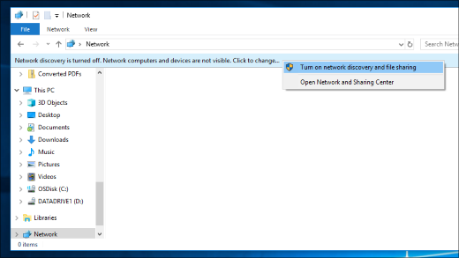Go to File Explorer, got to network on the left side and turn on network discovery.
2. Go your machine (**hostname** in PowerShell will give the machine’s name) what is the contents in this file?

The files I specified to be shared

1. Now that we have an SMB file lets map it as a local drive to do this enter the command:

**New-SmbMapping -LocalPath ‘Z;’ -RemotePath \\$env:COMPUTERNAME\smbtest**

1. Now that the file is mapped to a drive it can be more easily accessed by:

**cd Z:**

1. Let’s see if this modifying this file changes the contents in psfiles

**Mkdir Testdir**

1. Did it work, what was the error?

Access denied

1. Who has access to smbtest?

**Get-SmbShareAccess -Name smbtest**

Authenticated users

1. To give access to your user enter

**Grant-SmbShareAccess -Name smbtest -AccountName $env:USERNAME AccessRight Full**

1. Let’s see if this modifying this file changes the contents in psfiles

**Mkdir Testdir**

1. Now go to your psfiles location and see if there is a new directory named “Testdir” was it changed in both locations?

Yes it was

Task 2 – Clean up

To remove Testdir:

**rmdir testdir**

To remove access to the file:

**Revoke-SmbShareAccess -Name smbtest -AccountName $env:USERNAME**

To remove share:

**Remove-SmbShare -Name smbtest**